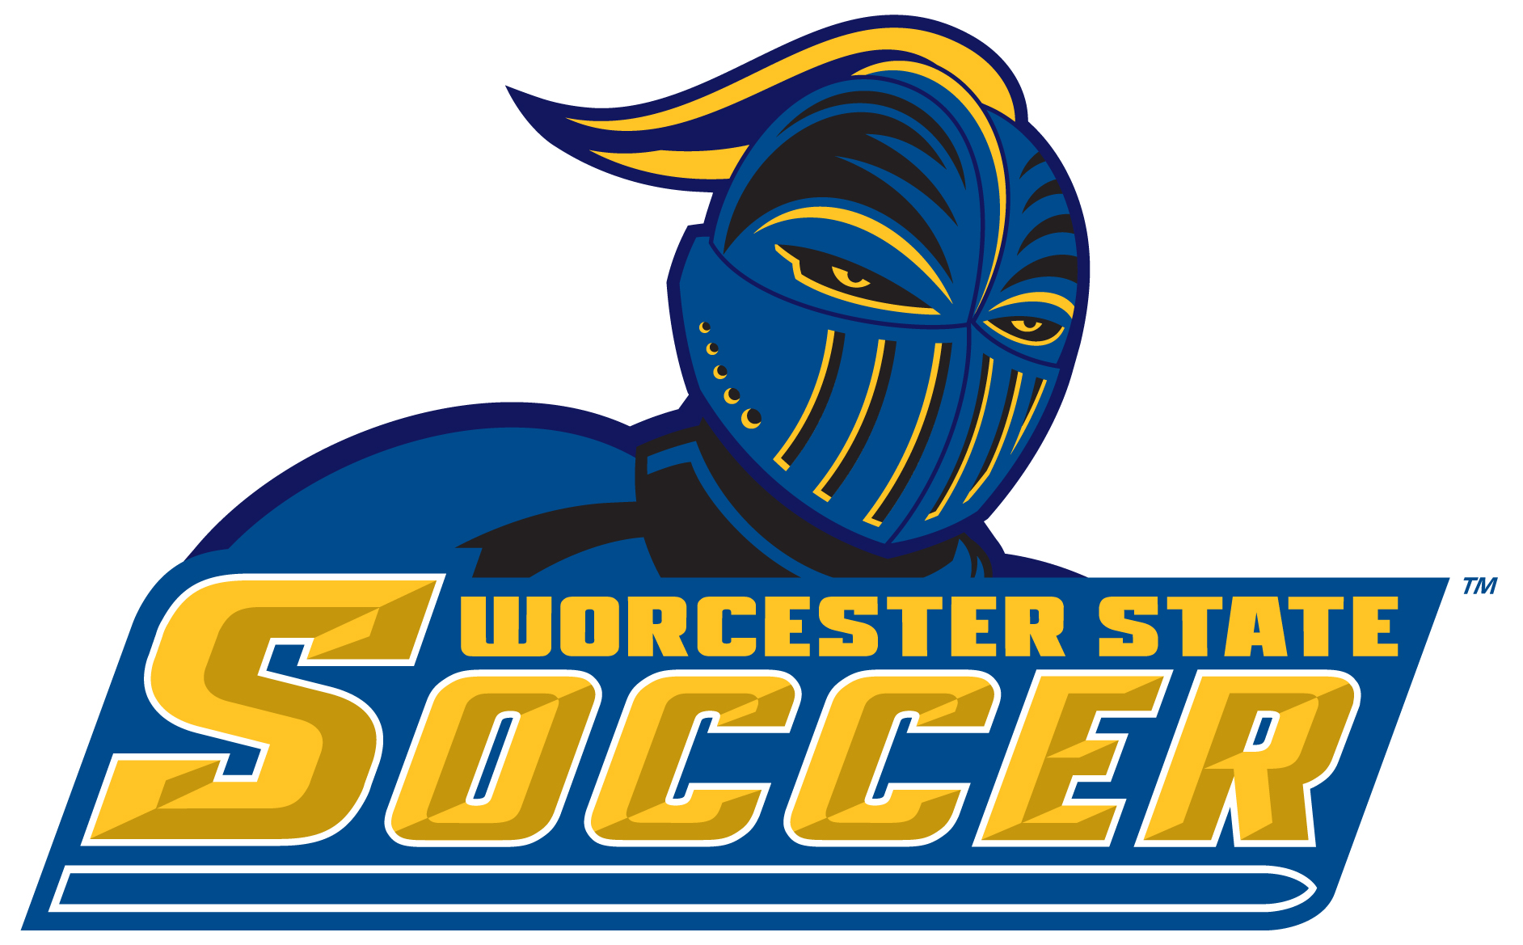

2018 Worcester State University Women’s Soccer Roster

00 Ashley Spellman So. GK 5-5 Lancaster, Mass. / Nashoba
1 Jill Zinkus So. GK 5-5 Grafton, Mass. / Grafton
2 Fiona Weir Fr. D 5-2 Boston, Mass. / Boston Collegiate Charter
3 Jennah Kellie So. M 5-3 Manchester, Conn. / Manchester
4 Megan Gurlitz So. M 5-4 Auburn, Mass. / Auburn
5 Tayla O’Leary So. F 5-4 Salem, Mass. / Salem
6 Hannah Foster Fr. M 5-8 Worcester, Mass. / Doherty
7 Valerie Gordon Fr. F 5-1 Lowell, Mass. / Lowell Catholic
8 Jenna Martin Sr. M 5-5 Salem, N.H. / Central Catholic
9 Maddie Fong So. M 5-4 Norton, Mass. / Coyle and Cassidy
10 Skylar Alves Jr. F 5-1 Ashburnham, Mass. / Oakmont
11 Jill Anderson So. M 5-2 Spencer, Mass. / David Prouty
12 Kass Liquori Fr. D 5-6 Enfield, Conn. / Enfield
13 Amber Lempke So. D 5-4 Holyoke, Mass. / Holyoke
14 Maggie Symonds Fr. M 5-0 Windham, Maine / Windham
15 Apphia Donoghue Fr. M/D 5-4 Rowley, Mass. / Triton Regional
16 Ali Maldonado So. F/M 5-7 Rutland, Mass. / Wachusett
20 Nicole Gifford Sr. D 5-4 Rochester, Mass. / Old Rochester
21 Kelsey Bergquist Fr. D/M 5-5 Groton, Mass. / North Middlesex
22 Nikki DiPilla Sr. F/M 5-8 Sterling, Mass. / Wachusett
23 Jenna Matthew Jr. D 5-2 Auburn, Mass. / Auburn
25 Talia Borci So. F 5-3 Leicester, Mass. / Leicester
26 Christina Spinos Jr. D 5-2 Wilmington, Mass. / Wilmington
99 Tori Socci Fr. GK 5-7 Blackstone, Mass. / Blackstone Valley

Head Coach: Kevin Cumberbatch
Assistant Coaches: Chris Kirwan, Cassie Giardina, Nicole Parenteau
Captains: Jenna Martin, Nicole Gifford, Nikki DiPilla
Head Athletic Trainer: Jessica Meany
Assistant Athletic Trainer: Kevin MacLennan
Athletic Trainer: Jason Anderson

Pronunciation Guide:

12 - Kass Liquori - lick-ORR-ee
14 - Maggie Symonds - SY-monds
15 - Apphia Donoghue - ah-FEE-ah
22 - Nikki DiPilla - da-PILL-ah
25 - Talia Borci - BOR-chee
26 - Christina Spinos - SPEE-nos

